Why complete our Job Simulation
Experience the world of EY Forensic & Integrity Services through an immersive job simulation that provides a hands-on opportunity to understand how EY Forensics investigates fraud. The simulation offers a unique perspective on the importance of upholding ethics and integrity in the corporate world. For those passionate about making a positive impact and supporting transparency in business practices, this simulation is an invaluable opportunity to explore EY Forensics.
Self-paced 3-4 hours
No grades
No assessments
Intermediate
Welcome to the EY Forensic & Integrity Services virtual job simulation. We’re thrilled to have you here.
EY teams are experienced in supporting companies to respond to issues across a range of areas, including fraud, corruption and cyber. We help companies resolve commercial disputes and create a compliance environment where integrity is at the heart of what they do. We leverage our experience and utilize the latest forensic technology, assisting companies and their legal teams in thorough fact-finding, helping them proactively address risks associated with fraud, bribery and changing regulatory environments.
While forensics covers a vast array of activity, this simulation focuses on one key aspect: fraud investigations. These come in all shapes and sizes; no two are the same. Regardless of their nature, fraud investigations involve collecting evidence, analyzing vast amounts of data and piecing together information to solve a complex puzzle. It’s like being a leading-edge detective! This process also entails personal interactions, such as conducting interviews to gather insights from individuals involved, including potential perpetrators.
We believe this simulation will not only provide you with valuable skills and knowledge but also offer insight into forensics and how a career within this field can shape a business environment characterized by transparency, ethics and confidence.
Upon completing this simulation, consider exploring other careers with the EY organization through our diverse simulation programs. We recommend trying out the EY Climate Change and Sustainability Services (CCASS), EY Audit and EY Financial Accounting Advisory Services (FAAS) job simulation programs to further broaden your career possibilities.

View All
Skills you will learn and practice:
Impactful Communication
Global Perspective
Results Management
Learning Agility
Analytical Thinking
Critical Thinking
Problem Solving
Collaboration
Adaptability
Investigation Skills
View All
How it works
Complete tasks guided by pre-recorded videos and example answers from our team at EY. No live sessions, all self-paced.
Earn a certificate and add it to your resume and LinkedIn as an extracurricular activity.
Stand out in applications. Confidently answer interview questions and explain why you’re a good fit for our team.
Program Scenario
Welcome to the Forensic and Integrity Services Job Simulation
We’re so excited to have you here with us!
Your Role
You are working as an analyst in the EY Forensic & Integrity Services team.
Your Goal
To assist the EY Forensic & Integrity Services team in executing an engagement around fraud investigation.
Background of EY Forensic & Integrity Services (‘’Forensics’’)
The EY Forensic & Integrity Services teams help organizations to manage risk, investigate alleged misconduct, drive regulatory compliance, measure the financial implications of disputes, leverage forensic technology using robotics automation, advanced analytics and AI technologies, and digital and forensic analysis.
EY Forensic & Integrity Services is divided into seven solution sets:
- Investigations
- Integrity and compliance
- Discovery and analytics
- Privacy and cyber response
- Transaction forensics
- Disputes
- Crisis management and incident response services
EY Forensic & Integrity Services service offerings
1. Investigations
EY teams of investigators, forensic accountants, compliance professionals and technology professionals can help companies respond rapidly to instances of alleged fraud, bribery and other misconduct, as well as provide support throughout any subsequent regulatory, civil or criminal proceedings.
Using advanced forensic technologies and data visualization tools, EY teams gather facts and quickly identify relevant evidence to help mitigate potential damage caused by impropriety, including potentially corrupt payments, by newly acquired businesses or joint venture partners.
2. Integrity and compliance
Integrity is at the core of contemporary business; this means not only doing what is legal but also doing what is right. We work with companies to design, assess and improve their compliance programs, focusing on the right governance models for their organization and helping the EY team to be strong business partners working to prevent violations of regulations and laws. Many companies are looking to modernize their programs and leverage technology to deliver better insights and realize efficiencies.
3. Discovery and analytics
Organizations are seeking an end-to-end solution for collecting and processing the information stored in electronic devices such as laptops, company servers and mobile phones (e-discovery), to help them manage legal and compliance risks, and reduce cost. From pre-litigation information management to post-matter data disposition, EY teams’ qualiﬁcations, experience and scale help us to offer services across the broad range of the e-discovery lifecycle.
EY professionals have significant experience in helping manage high-profile, complex legal and regulatory responses and investigations. The teams strive to apply advanced analytics and artificial intelligence (AI) technologies to each phase of a matter, from collection validation and gap analysis, early case assessment, data processing, document review, production, depositions and evidentiary hearings, to trial preparation.
4. Privacy and cyber response
EY teams have assisted companies in responding to a range of cyber incidents, including personally identifiable information (PII) data theft, business email compromise, ransomware attacks and credit card theft. The teams combine cybersecurity and computer forensic experience with traditional investigative approaches, including interviewing witnesses, interrogating data, and examining physical and digital evidence to uncover all facts pertaining to a breach.
EY professionals are experienced in helping address regulatory inquiries and liaising with law enforcement authorities. As cyber breaches often span international borders, they tailor their procedures to the specific legal and regulatory requirements of each country involved in the investigation, including work with external legal counsel.
5. Transaction forensics
EY Transaction Forensics professionals assist organizations and legal counsel in identifying and reducing financial, operational and reputational risks inherent to mergers and acquisition transactions. They possess deep experience in anti-corruption due diligence, both pre- and post-close, as well as related investigations and compliance matters.
In addition, they are proficient in conducting in-depth risk analysis of fraud, bribery and corruption, money laundering, restrictions on trade and export, related-party transactions and conflicts of interest. We have global capabilities and resources to address potential issues in transactions across all geographies and industries.
6. Disputes
EY Claims & Disputes teams assist companies, government sectors, public entities, individuals and their legal counsel in the world’s most complex disputes. EY professionals provide advice and opinions on accounting, financial and valuation matters in international arbitration, litigation and other alternative dispute resolution forums, including expert determination.
7. Crisis management and incident response services
Competing demands can make it difficult for organizations to identify threats and prepare for crises. EY Crisis Management & Incident Response Services support business leaders by helping them to identify and monitor potential threats, developing and testing crisis plans and teams, and responding with speed and integrity when an incident occurs.
In this virtual job simulation, the experience will concentrate specifically on one of the key offerings mentioned above as Investigations.
If you’re interested in learning more about these service offerings, check out the webpage in the Resources section below:
Here are some resources to help you
Forensic and Integrity services | EY - Global
Forensic & Integrity Service Offerings | EY - Global
Wrap-up / Concluding Remarks
As we conclude this introduction, you now have a basic understanding of the vital role EY Forensic & Integrity Services plays in protecting businesses and upholding ethical standards. We are now ready to explore the more advanced aspects of the work we do helping clients investigate fraud.
In the following tasks you will learn about the techniques and tools forensic practitioners use to uncover and prevent fraud. You will tackle real-life examples, interactive cases, and apply problem-solving skills essential for forensic professionals. The skills you will learn will help expand your knowledge of our business and provide practical work examples to prepare you for opportunities with the EY Forensic & Integrity Services team. So, let's get started with the EY Forensic & Integrity Services virtual job simulation.
Task 1: Understanding Fraud Investigation and the Fraud Triangle
Task overview and message from EY
Great, now let’s get started on your first task!
What you'll learn
- Key techniques in fraud investigation
- Understanding the fraud triangle: opportunity, incentive/pressure, rationalization
What you'll do
- Knowledge checks to demonstrate your understanding of what the EY Forensics team does
- A crossword puzzle related to fraud investigations
H
Here is the background information on your task
Understanding fraud and its investigation
Welcome to the first step in your journey into Forensics!
As we kick off with Task 1, let's define what fraud entails before we dive into the specifics of the investigation and the framework we use to understand it.
What is fraud?
Fraud is the intentional act of deceiving or misleading someone for the purpose of obtaining an unauthorized benefit, typically involving the manipulation of information or the concealment of the truth. Fraud can include attempted fraud.
(A misleading conduct done by someone, with the objective to get an illegal personal advantage.)
It's a critical for organizations to vigilantly guard against fraud, and this is where our role as forensic analysts is important. By identifying and understanding the various forms of fraudulent conduct, we can better support organisations in identifying and managing their fraud risks.
What is a fraud investigation?
The fraud investigation process involves scrutinizing and analyzing alleged fraudulent conduct to collect evidence, identify the individuals responsible, ascertain the magnitude of financial damage, and support the possibility of legal proceedings or corrective actions.
In simple terms, think of a fraud investigation as being similar to a detective's work in solving a crime, but instead of looking for physical clues, forensic practitioners search for financial discrepancies and irregularities that could indicate fraud. Investigators look through financial records and use special accounting skills, advanced forensic technologies and legal knowledge to find evidence of fraud, such as asset misappropriation, bribery or fraudulent financial records. Their job is to find supporting evidence, identify involved individuals, quantify financial losses and, when asked to, provide support as professionals through legal proceedings.
Presented here are real-world case studies that showcase the variety of fraud investigation initiatives conducted by Forensics teams:
The issue | Actions taken | Outcomes
A major company defaulted on a debt worth billions of US dollars, with subsequent investigations revealing financial irregularities and alleged fraudulent activities in loan disbursement and project allocation. | The Forensics team conducted a thorough financial audit and investigation into the company's records, uncovering evidence of fraudulent activities and irregularities. | The Forensics team provided detailed reports to the authorities, which led to the criminal charges against the executives and officials involved.
A company was accused of manipulating the procurement process of crude oil, favoring specific suppliers and receiving bribes. A government authority is now investigating the allegations. | The Forensics team was engaged to analyze the procurement process and identify any patterns or evidence of manipulation or bribery. They used forensic data analytics to trace financial transactions and assess the integrity of the procurement process. | Findings from the Forensics team were submitted to the government authority for further investigation.
Instances of price manipulation were reported in the pharmaceutical sector, particularly involving government procurement of medicines and medical equipment. Several pharmaceutical companies were found to be overcharging for their products under a government program, allegedly involving inappropriate financial incentives to government officials. | The Forensics team investigated the pricing strategies and financial records of the pharmaceutical company in question, then evaluated the procurement contracts. The team also looked for evidence of financial incentives to government officials. | The Forensics team identified overcharges and discrepancies while reviewing the procurement contracts. Findings related to financial incentives and other issues, as identified during the review of documents, were shared with the company management.

Fraud investigation: techniques and essential skills
When it comes to investigating fraud, EY has a team of practitioners who have special skills to investigate different parts of an allegation of fraud. This team interview individuals, use data analytics to find patterns in data and document review tools to look at emails. Our tools can leverage AI to build up evidence of actions and decisions that support the identification of inappropriate activities.
In this section, you will learn about these techniques the EY Forensic & Integrity Services teams use and essential skills they have to investigate a fraud case. From evidence collection to analyzing data and reporting our findings, our specialists are equipped to handle complex challenges and deliver information to our clients on potential fraudulent activities.
Evidence collection:
Objective: Collect all relevant documents, transaction records, communications and other information for the investigation.
Responsible owners:
• Fraud investigation team: Collect and list all documents and secure transaction records.
• EY Forensic & Integrity Services technology team: Archive email, electronic communications and other digital evidence that may be relevant.
Deliverables: Compile evidence relevant to the case.
Data analysis:
Objective: Conduct thorough data analysis to identify patterns, anomalies, and trends that suggest fraud.
Responsible owners:
• Data analysis team: Perform statistical analysis and data mining.
• Fraud investigation team: Analyze findings and link them to potential fraud indicators.
Deliverables: Provide a detailed report on suspicious activities and data irregularities.
Interviews:
Objective: Gather information and insights from involved parties, witnesses and suspects about the fraud.
Responsible owners:
• Investigative interviewers (specializes in conducting interviews): Conduct interviews and document outcomes.
• Fraud investigation team: Organize interview schedules and provide support.
Deliverables: Record statements and interview notes summarizing key information.
Forensic examination:
Objective: Apply forensic techniques to discover and analyze digital evidence on devices.
Responsible owners:
•EY Forensic & Integrity Services technology team: Conduct device forensic analysis, assist in securing devices and maintain the chain of custody.
Deliverables: Provide a forensic analysis report with digital evidence findings and their implications.
Collaboration:
Objective: Collaborate with client and other advisers for a thorough investigation.
Responsible owners:
• Legal and compliance team: Work with external or internal legal teams.
• HR teams of Client stakeholders may be involved as well as members of their management or the board.
• Fraud investigation team: Manage communication and collaboration across all stakeholders.
Deliverables: Create a collaboration framework and hold regular progress meetings.
Reporting:
Objective: Summarize responses to the investigation.
Responsible owners:
• Client’s legal counsel: Guide on legal proceedings and compliance issues.
• Client’s compliance officer: Confirm all actions adhere to regulatory standards.
Deliverables: Provide a report supporting documents for the client to undertake the appropriate actions (e.g., law enforcement, disciplinary steps).
Understanding the Fraud Triangle
Now that you have a better understanding of fraud and the investigation process, let’s explore the Fraud Triangle framework that helps detect the factors that lead to fraudulent behaviour.
Fraud Triangle
The Fraud Triangle was developed by criminologist Donald R. Cressey in the 1950s. The model outlines three elements that are typically present when fraud occurs: incentive/pressure, opportunity and rationalization. Cressey's Fraud Triangle is a foundational theory in the field of forensic accounting and fraud examination, providing a framework for analyzing the risk of fraud within organizations and the behaviors of individuals who commit fraud. For more details, you can read the concept of the Fraud Triangle online.
- Opportunity arises from weak internal controls or lack of oversight, which we address by identifying and reinforcing potential vulnerabilities within the organization's processes.
- Incentive/Pressure, whether financial or otherwise, can lead a person to feel they must undertake actions which may not be in line with process or even dishonest. In working with clients, we consider how internal pressures such as meeting budget or targets, or remuneration and bonus schemes might impact employee behavior.
- Rationalization is the process by which individuals justify their actions. Justification can come from a range of behaviors including “I am entitled”, “my company had adequate resources”, “I am not stealing, I am only changing numbers”.
By considering the principles of the Fraud Triangle into the investigative approach, the Forensics team not only gains an understanding of the existing issues but also is able to provide insight to their client as to cultural factors that can be address that may prevent future fraudulent conduct.
Click the image to see it in full size.
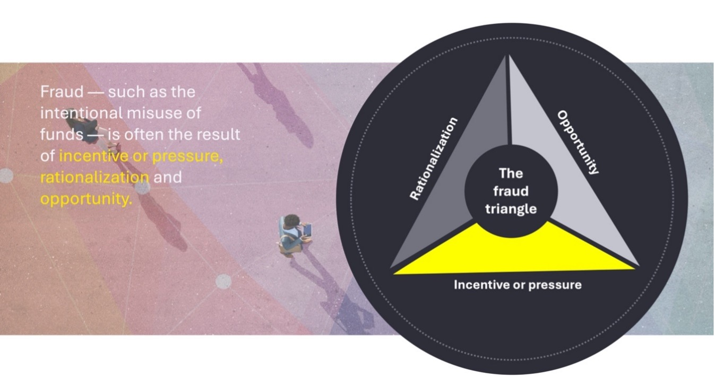
Here are some resources to help you
Investigations | EY – Global
Task 2: Deconstruction of whistleblower complaints
- 1
- 2
- 3
- 4
- 5
- 6
- 7
- 8
- 9
Task overview and message from EY
Nice work on Task 1! Now that you understand what a fraud investigation involves, in this task, we’ll take a look at one of the main sources of information to trigger the execution of an investigation.
What you'll learn
- How EY Forensic & Integrity Services can obtain information to trigger an investigation.
- What speak-up processes are and their critical role in maintaining an ethical workplace.
- What whistleblower hotlines are and how companies use them to initiate investigations.
- What is considered sufficient information to start an investigation.
What you'll do
- Understand how whistleblower hotlines operate and their role in investigations.
- Gather information and present it as one complete report.
- Rank the steps EY Forensic & Integrity Services takes in the process of preparing for an investigation.
Message from EY
Skills to accomplish
Forensic investigation knowledge
- Understanding of investigation procedures, methodologies and leading practices
Communicating with impact and driving outcomes
- Skill in summarizing complex information into organized and concise written descriptions
- Proficiency in creating detailed documentation, including work plans, procedures and supporting documentation requirements
Problem-solving
- Proactive problem-solving skills to anticipate potential challenges and propose solutions
Here is the background information on your task
Introduction to speak-up processes and whistleblower hotlines
Welcome to Task 2, where you will learn about the critical role of "speak-up processes" in maintaining an ethical workplace. Before we dive into the specifics of your task, let's look at the definition of the speak-up processes.
What are "speak-up processes"?
"Speak-up processes" are a set of procedures that companies put in place to help employees, contractors and other stakeholders report any concerns or misconduct they might observe at work. A speak up process is important as it may enable a company to gain an understand of an issue and address a problem before it becomes a significant issue. The activities are part of maintaining a safe and ethical work environment.
One key component of such processes is a "whistleblower or speak- up hotline." This is usually a dedicated phone number or online service that employees, contractors and other stakeholders can use to report issues, anonymously if they wish. They might report concerns including suspected fraud, safety hazards, harassment or other illegal activities they believe are happening at the company.
The idea is to make it easy and safe for employees, contractors and other stakeholders to speak up without fear of being punished, or treated unfairly, for reporting these concerns.
The company investigate reports made to find out if they are substantiated. This helps to build trust within the company and ensures that everyone is working according to the rules and values of the organization.
Internal regulations for a whistleblower hotline typically include the following elements:
- Confidentiality: The identity of the whistleblower is kept confidential to protect them from any potential retaliation or harassment.
- Anonymity: In some cases, the channel may allow for anonymous reporting, although this can sometimes complicate the investigation process.
- Independent administration: The hotline may be managed by an outside entity to confirm impartial oversight.
- Accessibility: The channel should be easily accessible to all employees and stakeholders, often available 24/7, and may include multiple reporting options such as phone lines, email, web forms or postal mail.
- Ongoing communication with the whistleblower: There should be mechanisms for ongoing communication with the whistleblower.
- User-friendliness: The platform should be intuitive, guiding users smoothly through the reporting process.
- Efficiency and effectiveness: The hotline should confirm that reports are managed promptly, consistently and appropriately.
Background information on the global company featuring in the remaining tasks
Now that you understand the importance of speak-up processes, let's explore how they work in an example scenario. In the upcoming sections, we will delve into a case study involving ABC Group, a global company that has received whistleblower complaints.
Before we dive into the details, let’s have a look at ABC Group and the other entities involved. Understanding the structure and relationships between the relevant parties will provide a clear context for the tasks ahead.
Overview of entities covered in upcoming tasks:
- ABC Group: a holding company, located in the US, involved in the business of construction and rental of warehouses around the world. ABC has received whistleblower complaints regarding misconduct against certain group employees. <<part of Task 2 and Task 4>>
- Two of ABC Group's global suppliers, one based in the UK and another in Peru, have noted misconducts on part of employees of DEF, and have raised separate anonymous whistleblower complaints to ABC. <<part of Task 2 only>>
- DEF Private Limited: one of the wholly owned subsidiaries of ABC Group, located in India. DEF employs the team members against whom allegations have been made by vendors (see below) in the whistleblower complaints. <<part of Task 3 and Task 4>>
- XYZ LLC: a supplier of capital goods to DEF Private Limited, located in China. ABC exercises its right to audit, in accordance with the contract agreed between DEF Private Limited and XYZ LLC. <<part of Task 4 only>>
EY Forensic & Integrity Services was engaged by ABC. As ABC is a global company, it engages EY Forensic & Integrity Services in each of its territories around the world when such services are required.
Below you can find the organizational structure of the entities involved. This will help you understand the interconnections of the different entities in scope for the investigation and can be a useful tool as you navigate through the following tasks.
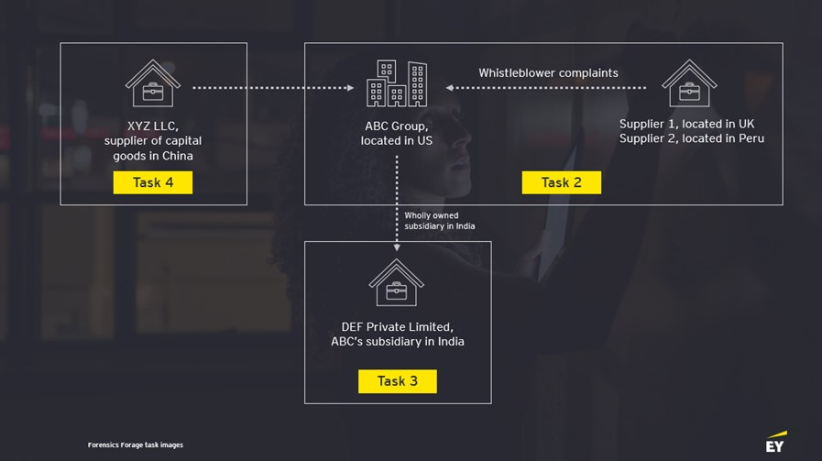

Disclaimer: Please note that ABC Group and all other entities involved in this case study are entirely fictitious. Any resemblance to real companies, past or present, is purely coincidental and is not intended to represent any actual business or event.
Let's get started
ABC Group is recognized for its strong commitment to ethical conduct and has earned a reputation for high ethical standards. The company takes every issue seriously, whether it concerns its employees or its vendors.
DEF Private Limited is constructing warehouses in Peru and UK as they are extending their business therein. As part of this expansion, DEF has appointed multiple vendors for carrying out the construction work.
Recently, ABC Group received whistleblower complaints from two of its suppliers, one based in the UK and another in Peru, against DEF Private Limited. The complaints, which were submitted anonymously through the company's whistleblower hotline, contained allegations regarding interactions with other suppliers.
In response to the complaints, ABC Group engaged EY Forensic & Integrity Services to investigate. The whistleblower reports were shared with the EY team to facilitate the commencement of the investigation.
Generally, when handling whistleblower allegations, EY Forensic & Integrity Services begins the investigation by creating a complaint-deconstruction note. This document breaks down the whistleblower’s complaint into key points (extracted from the whistleblower letter) and aligns them with the proposed investigative steps.
Here are some resources to help you
Summary of concerns raised by suppliers regarding ABC's recent administration
Two suppliers of ABC Group, one based in the UK and the other in Peru, have reported a series of irregularities and concerns regarding unethical practices in the procurement and contract allocation processes within ABC's wholly owned subsidiary, DEF Private Limited. These concerns highlight potential misconduct that warrants immediate attention.
Unusual patterns in contracts allocation
It has been observed that a disproportionate number of contracts, specifically those related to warehouse construction, are being awarded to new players both in UK and Peru. This pattern has raised suspicions, as these competitors seem to be favored regardless of the competitiveness of their bids. There is possibly a close personal relationship between the procurement managers of DEF (UK and Peru) and representatives of these favored competitors.
Signs of wrongdoings by employees of DEF Private Limited
The integrity of the bidding process has been called into question. Conversations have been overheard among employees, suggesting that some suppliers may be obtaining contracts through unethical means, including the provision of illicit benefits to individuals in decision-making positions. Additionally, the pricing offered by the favored competitors is less competitive than that of other bidders.
Other financial transactions
Reports indicate that three employees, two in UK and one in Peru, have demanded financial favors from certain suppliers in return for preferential treatment in the bidding process. This practice is not only unethical but also illegal and undermines the principles of fair competition. Several suppliers have also expressed concerns about the integrity of the bidding process, indicating that it is not an isolated perception but a widespread issue. The recurring success of the new contractors in securing larger bids or contracts, despite these concerns, is alarming and warrants immediate investigation.
Call to action
The suppliers urge the legal and compliance team at ABC to take these allegations seriously and conduct a thorough and impartial investigation into these matters. It is essential to uphold the ethical standards that ABC purports to maintain and to confirm that all business dealings are conducted in a fair and lawful manner. The reputation of ABC, the trust of its clients and the morale of its employees are at stake.
Task overview and message from EY
Great work on Task 2! In this task, we’ll look at how you investigate the alleged fraud.
What you'll learn
- How to identify risk factors related to personal assets and other investments of individuals under investigation.
What you'll do
- Analyze the financial details of the employee under investigation, identifying red flags and discrepancies in the information.
Message from EY
Skills to accomplish
Problem-solving skills
- Creativity in approaching complex problems and finding effective ways to uncover hidden information
Analytical skills
- Ability to analyze financial aspects and identify discrepancies
- Skills in forensics to trace the source of funds and understand the financial transactions that led to the purchase of properties and luxury items
Critical thinking
- Analyzing the situation, identifying the root causes and proposing solutions
Here is the background information on your task
Understanding ‘red flags’ in Forensic investigation
As part of this task, you will engage in a critical component of a forensic investigation by analyzing the financial activities of an employee suspected of misconduct. You will identify and document any red flags that could suggest the use of funds obtained through illicit means. This exercise will give you a sneak peek into the process of forensic analysis and the identification of potential fraud indicators.
What are red flags?
Red flags are warning signs or indicators that something may be improper and warrant further scrutiny. They can manifest in various forms and are often detected during a meticulous review of the subject's assets, investments and financial transactions.
For investigators, recognizing these red flags is a fundamental skill. Some common examples of red flags include:
- Living beyond means: This occurs when an individual's lifestyle expenses and purchases are inconsistent with their known legitimate income sources. For instance, if an employee earning a modest salary suddenly starts driving a luxury car, purchasing expensive jewellery or taking lavish vacations, these could be signs that they have access to funds not accounted for by their income.
- Sudden acquisition of expensive items: If there is a noticeable and unexplained increase in the acquisition of high-value assets such as property, art or other investments, especially without corresponding financial disclosures, this could suggest that the funds used for these purchases may have an illicit source.
- Inconsistencies in financial records: Discrepancies between an employee's reported income or inconsistencies in their financial statements and tax returns can be indicative of efforts to conceal the true source of funds.
- Unusual financial transactions: Transactions that do not fit the usual pattern of the employee's financial activity, such as large cash deposits, frequent transfers to offshore accounts or transactions involving secrecy jurisdictions, may signal an attempt to launder money.
- Complex financial arrangements: Complex corporate structures, trusts or other legal entities to hold assets can sometimes be used to obscure ownership and the origin of funds.
- History of ethical violations: Past behavior involving ethical breaches or minor fraud can be a precursor to more significant fraudulent activities.
- Resistance to providing information: An employee's reluctance or refusal to provide necessary financial documents or explanations for certain transactions can be a red flag.
Let's get started
After initiating the investigation, following the whistleblower complaint in Task 2, EY Forensic & Integrity Services team reviewed the electronic data for three employees, as alleged in the whistleblower complaint. On review of company records and publicly available information, the EY team has gathered some additional data regarding entities connected to the individuals giving insights into the assets, income streams and other investments belonging to the employees under investigation.
Social media has also been reviewed to identify activities and connections of the three individuals.
Upon reviewing the electronic data of the employee in question and considering social media, the EY teams uncovered indications suggesting a discrepancy between the employee’s reported earnings from the company and their lavish lifestyle.
Here is your task
Your task is to identify and document any discrepancies or ‘red flags’ in the data related to one of the employees facing allegations, which could suggest the use of funds obtained illicitly. Additionally, you should document what further information and evidence you would need to conclude that fraud has been committed.
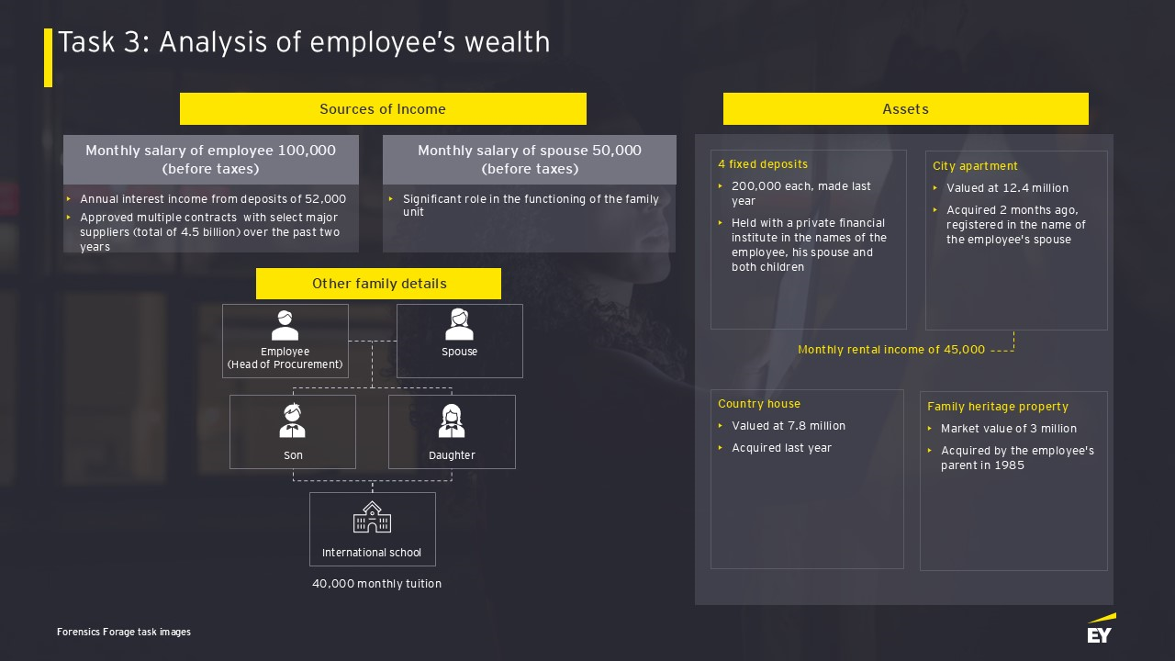
To record your findings, please use the attached template
Wrap-up / concluding remarks
Summary of findings
The investigation found that the employee's wealth and spending do not match his salary. There are signs he might have other undisclosed income sources which could be illicit or improper in nature, such as receipts from vendors, as the scrutiny of records also indicated instances of preferential treatment toward certain vendors.
These observations, coupled with the disproportionate wealth, call for a detailed explanation from the individual in question.
To investigate such cases, forensic accountants and investigators typically employ various methods, including:
- Reviewing financial records and transactions for inconsistencies or anomalies
- Conducting interviews with the employee and other relevant individuals
- Analyzing the employee's lifestyle and spending patterns in relation to their income
- Utilizing data analytics and other technological tools to trace and identify suspicious activities
- Collaborating with legal practitioners to confirm compliance with laws and regulations during the investigation
It is crucial to handle the investigation with confidentiality and due process to confirm that the rights of the individual are respected and to maintain the integrity of the investigation.
Task overview and message from EY
Nice work on Task 3! Management of ABC and DEF were impressed with how EY Forensic & Integrity Services investigated, concluded and reported on this instance of fraud raised by internal whistleblowers. Unfortunately, ABC has identified another concern. In this task, we'll look at analyzing financial documents and collaborating with EY Forensic & Integrity Services teams across borders.
What you'll learn
- How to identify potential risks or issues with financial documents
- How to prepare internal briefing materials
What you'll do
- Analyze a sample purchase order (PO), invoice, credit note and fixed asset register (FAR)
- Draft briefing materials for another EY team in a different country
Skills to accomplish
Analytical thinking
- Reviewing data presented on different financial documents, investigating for inconsistencies or inaccuracies
Collaboration and coordination
- Emphasizing the importance of effective collaboration and coordination among teams
Effective communication
- Articulating ideas clearly and professionally in written communication
Problem-solving
- Proactive problem-solving skills to anticipate potential challenges and propose solutions
Here is the background information on your task
Below is a reminder of the group structure of ABC, and the suppliers involved in the scenarios created throughout these tasks.
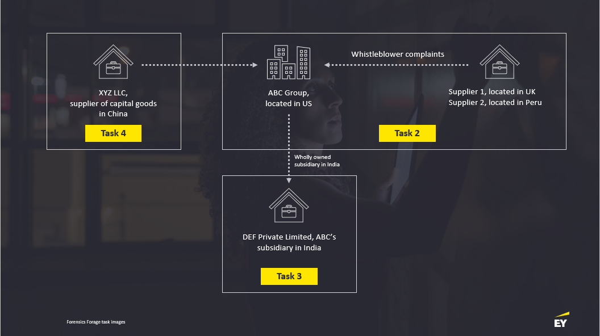

Click on the navigation bar on the left-hand side to go back to Task 2, Slide 4 to re-read through the organizational structure and entity details. Then return to this page to continue the task.
In this task, you will focus on ABC’s subsidiary company in India, DEF, and their relationship with a supplier of capital good based in China, XYZ LLC.
During an internal investigation, the company has identified that DEF were purchasing goods, from the supplier in China, at much higher rates than the prevailing market prices. To fully investigate the situation would require access to both the financial records of DEF and those of XYZ LLC. The ABC group, based on its contractual terms, reserves the right to audit its suppliers using a third party.
Based on the previous good work performed, and the global footprint of the company, the ABC group wishes to engage EY to conduct the investigation. This requires teams in both India and China.
Part 1: Document analysis
In this first part of the task, the EY team has been given a sample of documents used in the internal investigation. Your task will be to review the documents and identify potential risks or issues within.
Below you will see a link to the documents, followed by an explanation of what each document is, how they link together in a purchase process and what risks you should look out for.
- Sample purchase order issued by DEF Private Limited to XYZ LLC
- Invoice received from XYZ LLC
- Credit note received from XYZ LLC
- Fixed asset Register of DEF Private Limited
A purchase order, an invoice, a credit note, and a fixed asset register are all integral components of the accounting and procurement processes within a business. Here's how they are defined and linked:
1. A purchase order is a document issued by a buyer to a seller, authorizing the purchase of goods or services at specified prices and terms. It serves as a contractual agreement before the delivery of the goods or services.
2. An invoice is a document issued by a seller to a buyer that lists the goods or services provided, their quantities and the prices charged. It serves as a request for payment and includes details such as the invoice date, payment terms and due date.
3. A credit note is a document issued by a seller to a buyer. It acknowledges the return of goods sold on credit, errors in an invoice or other circumstances that require a reduction of the amount due to the seller. It effectively reduces the amount owed by the buyer to the seller.
4. A fixed asset register is a comprehensive list of fixed assets owned by a business. It records the purchase, value, depreciation and disposal of the assets. Fixed assets are long-term tangible pieces of property or equipment that a firm owns and uses in its operations to generate income.
Link between these documents:
- When a buyer decides to purchase goods or services, they issue a purchase order to the seller, which details the items to be purchased, quantities and agreed prices.
- Upon fulfilling the order, the seller sends an invoice to the buyer, which should match the purchase order. The invoice requests payment for the goods or services provided.
- If there is a need to return goods, or if there is an error in the invoice or if the buyer has been overcharged, the seller issues a credit note. This document serves to adjust the amount on the original invoice, reducing the buyer's liability.
- If the purchased items are long-term assets, such as machinery or equipment, they are recorded in the fixed asset register. The register tracks the cost, depreciation and other financial aspects of the assets over their useful life.
The link between these documents is crucial for accurate financial accounting and asset management, and to confirm that transactions are properly recorded and reconciled. They help in maintaining a clear audit trail, managing cash flow and ensuring compliance with financial reporting standards.
When reviewing documents such as purchase orders, invoices, credit notes and fixed asset registers during fraud investigations, it's important to be vigilant and look for discrepancies that could indicate fraudulent activity. Here are some potential risks and clues to look out for in each document:
1. Purchase order risks:
- Unauthorized purchase orders: Confirm that all purchase orders are authorized by the appropriate personnel.
- Price inflation: Compare prices on the purchase order with market rates to check for inflated prices.
- Quantity discrepancies: Match the quantities ordered with the quantities invoiced and received.
- Fictitious vendors: Confirm that the vendors listed on the purchase order are legitimate and have a history of transactions.
Example: A purchase order for an unusually high quantity of an item might suggest an attempt to siphon off goods.
2. Invoice risks:
- Duplicate billing: Check for multiple invoices with the same invoice number or billing for the same goods or services more than once.
- Overcharging: Compare the invoice amounts with the purchase order to see if there is an overcharge for goods or services.
- Phantom suppliers: Verify the existence of the supplier and the authenticity of the invoice details.
- Altered amounts: Look for signs of tampering with the figures or details on the invoice.
Example: An invoice number appearing twice in the records could indicate duplicate payments.
3. Credit note risks:
- Unjustified credits: Verify that credit notes are issued for valid reasons, such as returns or billing errors.
- Excessive credits: Look out for an unusual number of credit notes issued to the same customer or for the same items.
- Unauthorized issuance: Confirm that credit notes are authorized by the appropriate personnel.
- Link to original transactions: Confirm that each credit note is linked to an original invoice and matches the details.
Example: Multiple credit notes to a single customer without corresponding returns could indicate fraudulent refunds.
4. Fixed asset register risks:
- Ghost assets: Look for assets listed in the fixed asset register that do not physically exist or cannot be located.
- Improper depreciation: Check the depreciation methods and calculations for consistency and accuracy.
- Disposal irregularities: Verify that any disposals of assets are properly documented and authorized.
- Inconsistent records: Confirm that the fixed asset register matches up with physical audits and inventory checks.
Example: An asset with no physical presence or location details might be a ghost asset.
How to spot discrepancies and gaps:
- Cross-referencing: Always cross-reference invoices with corresponding purchase orders and delivery receipts.
- Audit trail: Confirm there is a clear and consistent audit trail for each transaction.
- Data analysis: Use data analysis tools to identify patterns that could indicate fraudulent activity, such as recurring round numbers or transactions just below approval thresholds.
- Physical verification: Conduct physical inspections of assets listed in the fixed asset register to confirm their existence and condition.
- Internal controls: Review the internal controls in place for issuing, approving and recording transactions to confirm they are robust and followed.
- Vendor verification: Perform background checks on vendors to confirm their legitimacy and past dealings with the company.
By being attentive to these potential risks and employing thorough investigative techniques, discrepancies and gaps that may indicate fraud can be identified and addressed.
Here is your task:
Open document below as Task 4 – Part 1 Template, identify potential risks or issues within these documents and provide a detailed analysis of each document. Pay close attention to details, discrepancies or any elements that may pose a risk.
Click this link to access the document: Task 4 – Part 1 Template
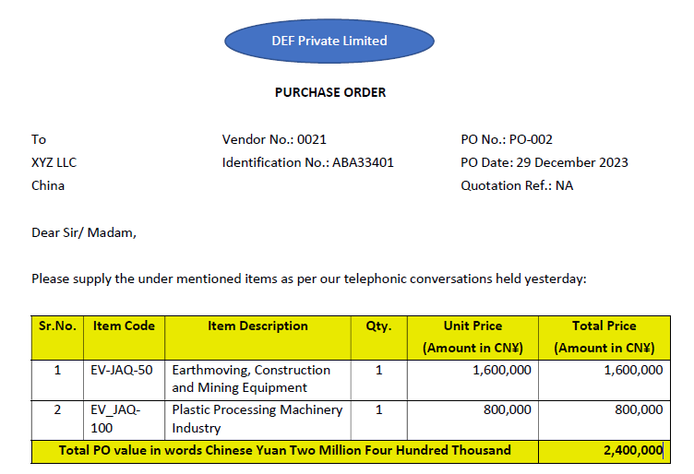
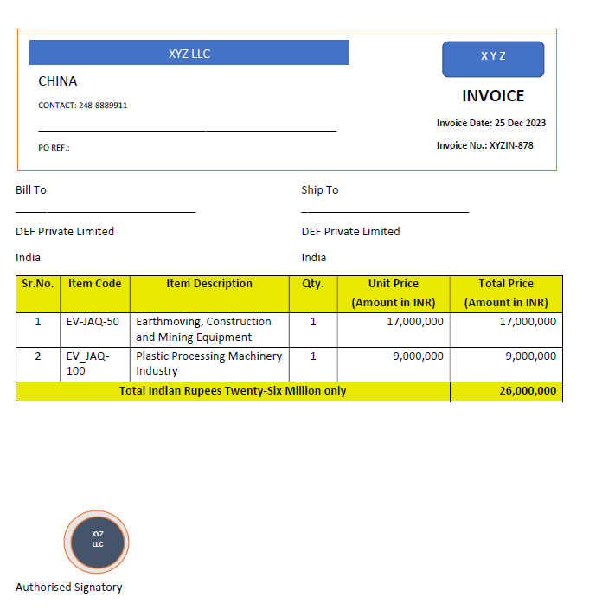
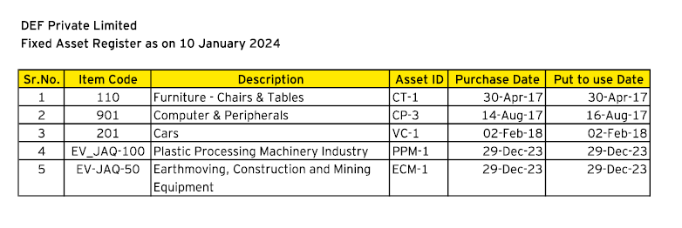
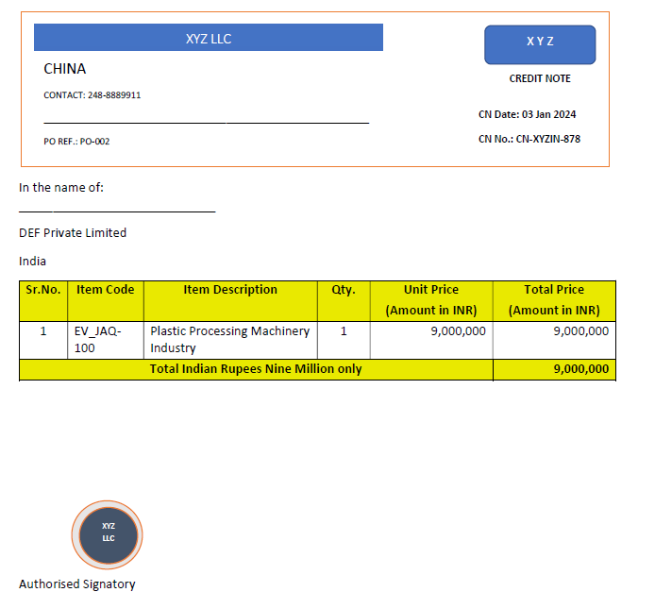
Part 2: Draft professional communications to EY Forensic & Integrity Services Team in China
ABC Group’s management has engaged EY Forensic & Integrity Services in India, and you are acting as a member of that team. Your first objective is to engage the EY Forensic & Integrity Services team in China and explain that you need their help to conduct an investigation. Your task is to prepare a professional written communication addressed to the EY Forensic & Integrity Services team in China that outlines the project’s overview, expectations for collaboration, next steps to move forward and schedule a virtual meeting with them. Your availability is Wednesday, Thursday and Friday after 2 pm India (IST) time.
Click below to access a template to document your answer.
When drafting a communication, you should consider the following
- Content and language that is clear and concise
- Details of who has engaged EY and the name of the Chinese supplier
- What you have learned about:
  - The business activities the group undertakes (which is provided in the information from previous tasks)
  - Detail the allegations related to the purchase of capital goods from XYZ by DEF
  - The sample documents used in the internal investigation in Part 1 of this task
- Explain why you need assistance from the EY Forensic & Integrity Services team in China and what specific support you expect from them at this stage.
- An indication on timeline to complete the investigation.
- Propose a practical and actionable plan as a follow-up to this communication.
Part 3: Briefing the EY China Forensic & Integrity Services team
Well done on completing Part 2. I hope you concluded in your communication that the next step was to arrange a meeting to properly brief the team. Preparing briefing materials for the meeting is what you will be doing in Part 3 of this task. The objective of the meeting is to discuss the detailed execution plan, and related procedures, for the review of transactions between XYZ and DEF.
Listen to the voice note that Vineet Kumar, the engagement manager, has left for you to learn more about what you need to do for the final part of this task.
Task 4, Part 3
Transcript of the voice note from Vineet Kumar

Manager:

Hello, I am Vineet Kumar, the engagement manager. I’m looking forward to working with you on this. There is a meeting scheduled with EY China Forensic & Integrity Services team this Thursday, for which I need your help to prepare briefing materials outlining the procedures to be performed and the evidence to be collected.

You’ve done a great job so far in understanding the connections between our client (ABC Group) and the different entities involved in this investigation. You’ve initiated the investigation, outlined the steps to address the complaint from the suppliers, and analyzed the financial activities of the employee suspected of misconduct at the client’s subsidiary in India. Plus, you’ve reached out to the EY China team for their support in investigating some allegations about the purchase of capital goods from a supplier in their region, which is fantastic.

Now, as you prepare the internal briefing materials, I want to highlight a couple of key areas for you to focus on:

First, we need the EY China team to understand the organizational structure of our client’s supplier in China (XYZ LLC) and which individuals interact with the client’s subsidiary in India (DEF Pvt Ltd), especially those responsible for contracting and transacting with them.

Second, the supplier in China is expected to share details of all sales to the Indian subsidiary, including the invoices raised and proof of delivery. But EY China should also consider what other documents might be required after gaining a thorough understanding of the company’s sales process. We want to gather enough evidence to identify any variances between the purchases recorded by the Indian subsidiary and the sales reported by the supplier in China.

If the supplier uses a freight agent, they’ll need to provide a signed and stamped freight agent authorization letter. And beyond just sales records, the EY China team should also investigate the cash receipts process. They’ll need to collect relevant bank statements, accounts receivable ledgers, or any other supporting documentation that shows how much money was received from the Indian subsidiary. It’s crucial to verify that the amounts were consistently recorded during the process for each transaction reviewed.

I hope this gives you a clear idea of the procedures to be performed and the supporting documentation to be collected. I would encourage you to think this through and ensure your briefing materials are clear and comprehensive. I look forward to reviewing your work.

And remember, if you have any questions about the task, just reach out. I’m here to help!
Procedures to be performed:
1.
2.
3.
4.
5.
6.
7.
8.

Supporting documentation to be collected:
1.
2.
3.
4.
5.
6.
Part 3: Example answer
Great work! Look at the example answer below to see how an EY Forensic & Integrity Services professional would have attempted this task. Think about what you did well and how you can improve.
Procedures to be performed:
- Understand which staff at XYZ have been in contact with DEF or have prepared or approved documentation that has been shared with DEF. Determine whether their role in XYZ is aligned with this activity.
- Document the end-to-end sales process to review completeness of documentation requests and to determine what controls are in place.
- Inspect the sales register of XYZ to identify the quantum of sales made to DEF during the period under review
- Reconcile the sales recorded in sales register by XYZ against the purchases recorded by DEF in its books of accounts. Additionally, reconcile the closing balances of accounts receivable for XYZ from DEF and accounts payable to XYZ by DEF in their respective books of accounts.
- Review XYZ’s quotations to DEF for consistency to each other. Compared against other customers for the same goods and benchmark against market price.
- Review all the documents that should prove delivery of capital goods to DEF.
- Perform sales sample testing for selected sales transactions made to DEF, reviewing all the documents in the process for each sale.
- Map the receipts made in the bank statements of XYZ with the payments made per the bank statements of DEF.
Supporting documentation to be collected from XYZ:
- Complete sales register of XYZ, highlighting the sales made to DEF for the period under review
- Ledger account of DEF in the books of XYZ.
- XYZ’s quotations to DEF
- Invoices sent from XYZ to DEF
- XYZ’s records of delivery (proof of delivery (POD))
- If the customer uses a freight agent, a freight agent authorization letter, which should be duly signed and stamped
- Bank statements showing amounts received from DEF
- Evidence that shows how payments received from DEF have been processed into the financial records of XYZ
Once the assessment at XYZ is completed, insights from the review of documents are to be linked to the observations noted from the review of electronic data of the employee and other public domain checks:
- Check who generally interacts with XYZ to share the PO.
- Confirm who prepares and approves the POs.
- Upon the receipt of invoices from XYZ, check who approves the invoices for payment clearance.
- Compare insights gathered with regard to the alleged personal benefits received by the employee (credits in bank accounts, buying any new assets, etc.) with the payments made to XYZ.

